**Equity in Healthcare Service Access**

Anvesh Ravipati

*ISQA 8900*

*Spring 2025*

**Abstract**

Disparities in healthcare access between rural and urban populations remain a persistent and pressing challenge in the United States, particularly among vulnerable groups such as individuals with disabilities, racial minorities, and low-income communities. These disparities are shaped by complex interactions among geographic, socioeconomic, and demographic factors, leading to unequal health outcomes and limited access to essential services. This study aims to analyze these disparities over the past decade and regional variations in public insurance utilization.

Using a mixed-methods approach, the analysis integrates five national datasets: Small Area Health Insurance Estimates (SAHIE), National Health Interview Survey (NHIS), Area Health Resource Files (AHRF), National Neighborhood Data Archive (NaNDA), and the American Community Survey (ACS). The study employs descriptive, spatial, and multivariate analyses to assess patterns in healthcare access, facility availability, workforce density, and insurance coverage across urban and rural settings.

Findings indicate that health disparities are most strongly associated with income level, urban-rural classification, and regional population growth—rather than race, provider counts, or clinic availability alone. The Southern region and non-metropolitan areas consistently reported worse health outcomes despite comparable infrastructure. These results suggest that improving healthcare equity will require not only expanding access to services but also addressing underlying socioeconomic inequalities. Policymakers should prioritize region-specific interventions and socioeconomic support to close persistent health gaps.

**Introduction**

Disparities in healthcare access between rural and urban populations continue to pose significant challenges in the United States, particularly for vulnerable populations such as individuals with disabilities, racial and ethnic minorities, and low-income groups. These inequities are deeply rooted in geographic, economic, and structural differences that shape individuals’ ability to obtain timely and appropriate care. Rural residents, in particular, often face limited availability of healthcare services, a shortage of providers, and greater distances to care facilities. These barriers can result in delayed diagnoses, unmanaged chronic conditions, and poorer overall health outcomes when compared to their urban counterparts.

The consequences of these disparities extend beyond individual health, impacting broader public health systems, regional economic stability, and efforts to promote health equity nationwide. As healthcare policy increasingly focuses on expanding coverage and addressing social determinants of health, it is critical to understand how these disparities manifest across different populations and geographic settings. Individuals with disabilities are especially affected by these barriers, as their health needs are often more complex and their access to services more dependent on supportive environments.

To address these gaps, this study investigates how disparities in access and utilization have evolved across urban and rural regions over the past decade and the broader structural factors influencing healthcare equity.

**Motivation**

In recent years, there has been a growing national focus on healthcare equity, particularly in light of persistent gaps in access and outcomes across geographic, socioeconomic, and demographic lines. Rural communities continue to face systemic barriers to care—including provider shortages, long travel distances, and underinvestment in infrastructure—resulting in preventable disparities in health status. These challenges are even more pronounced for individuals with disabilities, who often require more specialized services and face greater difficulty navigating fragmented care systems. Addressing these overlapping disadvantages is essential for building a more equitable healthcare system.

This research is motivated by the need to better understand the root causes and evolving nature of rural-urban healthcare disparities, particularly for disabled and economically marginalized populations. While many studies have documented such disparities, few have employed a comprehensive, multi-source approach that spans over a decade and includes both individual- and system-level factors. By integrating data from diverse federal sources, this study captures a fuller picture of how structural, demographic, and spatial variables interact to shape health access and outcomes.

Despite known disparities, few studies integrate longitudinal data from diverse federal datasets to analyze how structural, demographic, and spatial factors interact. This research fills that gap, offering new insight into the social and geographic dimensions of healthcare access and informing data-driven policy responses.

### ****Literature Review****

### The existing literature on healthcare disparities between rural and urban populations highlights a complex interplay of geographic, socioeconomic, and structural factors that contribute to unequal access to care. These disparities are particularly pronounced among underserved groups, including racial and ethnic minorities, low-income individuals, and people with disabilities. Synthesizing findings from recent and foundational studies reveals several recurring themes that inform the direction of this research.

#### **Geographic Disparities in Healthcare Access**

#### A large body of evidence consistently shows that rural populations face greater barriers to healthcare access than their urban counterparts. Studies such as Moon and Shin (2006), Gaffney et al. (2022), and Morales et al. (2020) underscore key challenges faced by rural residents, including fewer healthcare providers, longer travel distances, and a lack of specialized services. For example, Moon and Shin (2006) highlight disparities among Medicare-Medicaid dual eligibles, emphasizing the additional burden on rural populations due to provider shortages. Gaffney et al. (2022) report higher rates of chronic conditions like COPD in rural areas, directly linked to inadequate infrastructure. Morales et al. (2020) extend this analysis to mental health services, noting both a lack of professionals and the presence of social stigma, which further limits care utilization.

Bhatia et al. (2022) contribute to this evidence by showing that rural cancer patients are less likely to receive guideline-concordant care, primarily due to geographic limitations. This finding echoes the conclusions of Wolfe et al. (2020) and Gaffney et al. (2022), who link sparse healthcare networks in rural regions to poorer health outcomes, particularly for conditions that require sustained care. These studies collectively reinforce that geographic location is a primary determinant of both healthcare access and health outcomes.

**Socioeconomic and Demographic Factors**

The intersection of socioeconomic status, race, and access to care is another critical theme. Hardeman and Karbeah (2020) emphasize that structural racism plays a foundational role in perpetuating healthcare disparities, especially for racial minorities living in geographically isolated rural communities. Moon and Shin (2006) similarly point out that low-income, dual-eligible individuals—many of whom are racial minorities—face compounded barriers to care in rural areas due to limited provider availability and financial constraints.

Income is repeatedly identified as a central factor influencing healthcare access. Gaffney et al. (2022) report that low-income individuals in rural settings experience disproportionately high barriers to healthcare, including limited insurance coverage and unaffordable care. Wolfe et al. (2020) further emphasize the intersection of poverty and accessibility, noting that individuals with disabilities in rural areas are particularly affected by transportation costs and logistical challenges.

#### Zahodne et al. (2024) extend this conversation by examining neighborhood-level racial income inequality and its effects on cognitive health outcomes. Their findings align with those of Schneider et al. (2023) and Hardeman and Karbeah (2020), all of whom argue that economic disparities—both at the individual and community levels—exert a powerful influence on healthcare utilization and outcomes.

#### **Workforce and Infrastructure Challenges**

#### Another widely cited barrier to healthcare access is the shortage of healthcare professionals, particularly in rural areas. Morales et al. (2020) link workforce shortages to significant gaps in mental health service access, while Gaffney et al. (2022) detail similar issues in the delivery of specialized care for chronic conditions and disabilities. Wang et al. (2022) emphasize the difficulty of recruiting and retaining healthcare professionals in rural areas, even where facilities exist.

#### These findings are consistent with Bhatia et al. (2022), who found that limited provider availability in rural areas directly affects cancer care outcomes. Conversely, while urban areas tend to have more healthcare providers, demand often outpaces supply—leading to overcrowding, long wait times, and reduced care quality, particularly in low-income neighborhoods. These issues reflect disparities not in physical infrastructure alone, but in the ability of healthcare systems to meet population needs.

#### **Structural Barriers and Policy Implications**

#### Structural issues such as transportation are repeatedly identified as critical barriers to healthcare access. Wolfe et al. (2020) demonstrate that unreliable or unavailable transportation options significantly limit healthcare utilization in rural and underserved urban communities, a problem that disproportionately affects individuals with disabilities. Cross et al. (2021) further highlight how transportation barriers contribute to growing mortality gaps between rural and urban populations.

#### At the policy level, Agarwal et al. (2020) explore how initiatives like bundled payment models affect healthcare equity. While these models can reduce spending, they may fall short in addressing the complex, layered needs of rural and low-income patients. Their findings underscore the need for **flexible, patient-centered policies** that accommodate geographic and demographic diversity rather than applying uniform models across all settings.

### ****Objectives****

### This study aims to examine the structural, geographic, and demographic drivers of disparities in healthcare access and utilization across urban and rural areas in the United States. The specific objectives are:

1. To identify disparities in healthcare access across urban and rural populations, with analysis stratified by demographic factors such as age, race, ethnicity, and socioeconomic status, using data sources including AHRF and NHIS.
2. To analyze trends in healthcare service utilization over the past decade, and assess how these patterns have been shaped by factors such as workforce availability, facility counts, and insurance status.
3. To evaluate the relationship between health insurance coverage—particularly Medicaid and Medicare enrollment—and healthcare access and utilization, focusing on differences across demographic groups and geographic settings.

**Methods**

This study draws on five nationally recognized datasets to analyze healthcare access disparities across urban and rural populations in the United States. These datasets were selected based on their geographic coverage, temporal depth, and inclusion of variables central to understanding structural and demographic influences on health.

The Small Area Health Insurance Estimates (SAHIE) dataset, published by the U.S. Census Bureau, provides annual health insurance coverage estimates at the county and state levels from 2012 to 2022. It includes detailed demographic breakdowns by age, sex, race/ethnicity, and income level, allowing for the identification of coverage disparities over time and across regions.

The National Health Interview Survey (NHIS), administered by the Centers for Disease Control and Prevention (CDC), offers nationally representative microdata from 2019 to 2023. The Sample Adult Interview component includes detailed information on health status, access to healthcare, chronic conditions, and public insurance use (Medicaid and Medicare). The NHIS also incorporates urban-rural classifications based on U.S. Census and NCHS regional definitions, which were used to harmonize geographic distinctions across datasets.

The National Neighborhood Data Archive (NaNDA), maintained by the University of Michigan, provides neighborhood-level data on healthcare facility types and broader social determinants of health spanning from 1990 to 2021. This dataset is especially useful for assessing long-term trends in healthcare infrastructure and service availability such as outpatient, mental health, and home care services.

The Area Health Resource Files (AHRF), compiled by the Health Resources and Services Administration (HRSA), contain workforce and facility data for various health professions at the state level between 2018 and 2022. It includes counts and characteristics of over 37 healthcare occupations, enabling the calculation of workforce density and regional comparisons.

The American Community Survey (ACS), also conducted by the U.S. Census Bureau, provides annual population estimates and key demographic variables, including age, income, race, and disability status. ACS data from 2013 to 2023 were used to contextualize and normalize the population-based measures extracted from AHRF and NaNDA.

Urban-rural classifications were drawn from the NHIS dataset and are based on the National Center for Health Statistics (NCHS) definitions. These classifications were applied consistently across all datasets by matching on county or state identifiers, ensuring coherent geographic comparisons.

|  |  |  |  |  |
| --- | --- | --- | --- | --- |
| **Dataset** | **Source** | **Time Period** | **Geographic Scope** | **Key Variables** |
| **SAHIE** | U.S. Census Bureau | 2012–2022 | County and State | Health insurance coverage by age, sex, race/ethnicity, income |
| **NHIS (Sample Adult)** | CDC | 2019–2023 | National (region-based) | Health status, chronic conditions, access to care, Medicaid/Medicare use, urban-rural classification |
| **NaNDA** | University of Michigan ISR | 1990–2021 | County and State | Counts of health facilities (clinics, pharmacies, mental health, home care, etc) |
| **AHRF** | HRSA / Bureau of Workforce | 2018–2022 | State level | Healthcare workforce counts by occupation and demographics |
| **ACS** | U.S. Census Bureau | 2013–2023 | State level | Population |

**Results**

**1. Trends in Health Insurance Coverage (SAHIE)**

From 2012 to 2022, health insurance coverage in the U.S. steadily improved, with an average annual increase of approximately 0.3% with the most pronounced changes occurring in 2014 and 2015. Despite these overall gains, significant disparities remain.



When examined by sex, females reported consistently higher insurance coverage than males, with a difference of about 1 to 2 percentage points each year.

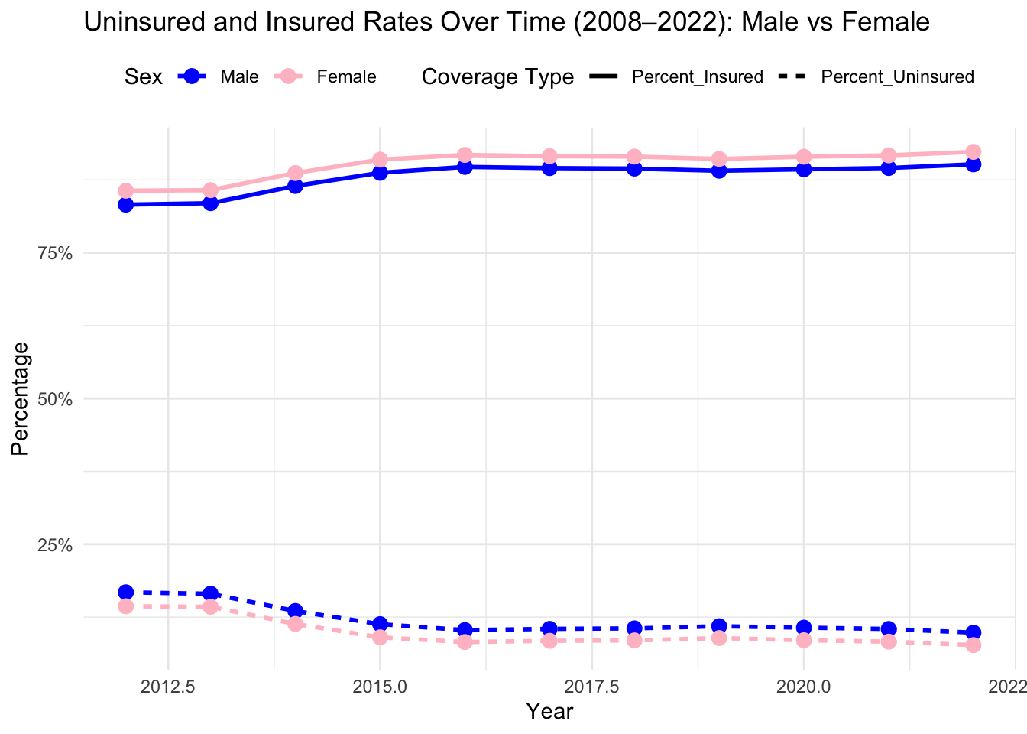

Black and White populations-maintained coverage rates near 90% across the period. In contrast, Hispanic populations had coverage rates that were 7 to 8 percentage points lower than those of Black and White populations throughout the decade.

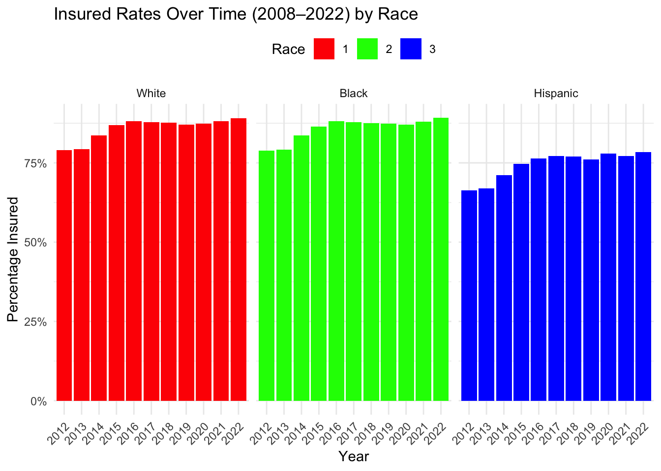

**2. Health and Access Trends (NHIS)**

Between 2019 and 2023, self-reported general health status declined modestly across the population. When analyzed by region, the Southern region consistently reported the lowest average health scores during this period. Survey responses were recorded on a five-point scale ranging from "excellent" to "poor" and were aggregated by region to allow for comparative analysis.

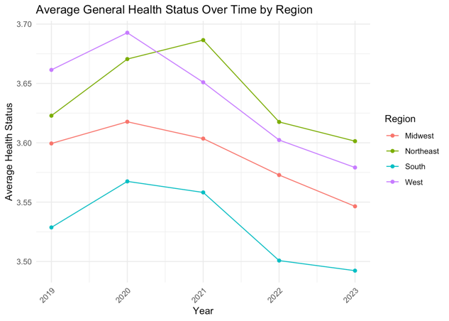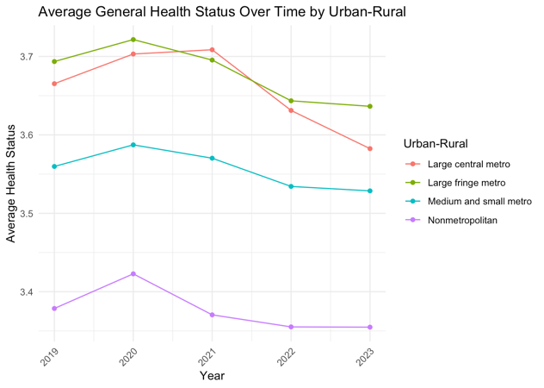

Utilization of public insurance programs increased across all regions over the five-year period. Both Medicaid and Medicare enrollment rose steadily from 2019 to 2023.

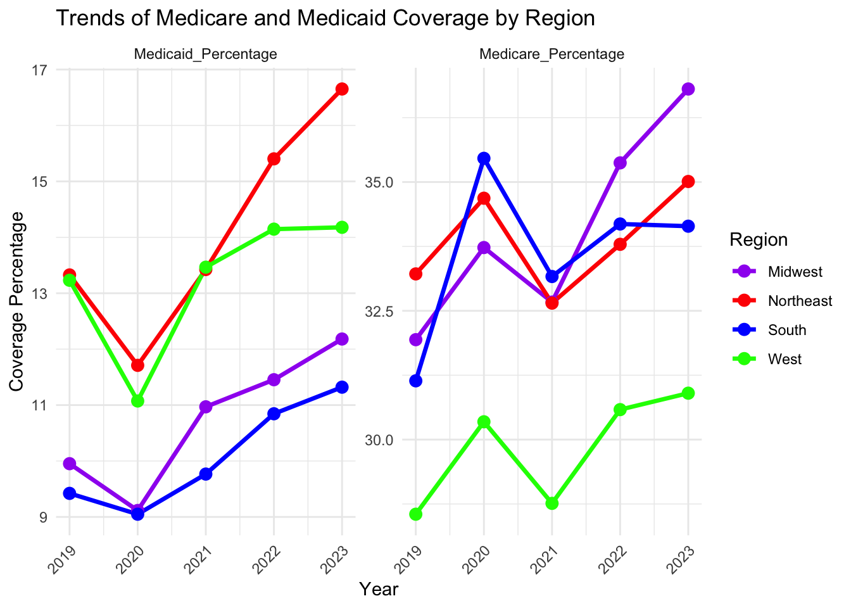

Individuals enrolled in Medicaid or Medicare were more likely to report certain chronic conditions. These included hypertension, high cholesterol, and chronic obstructive pulmonary disease (COPD), as well as difficulties related to mobility or cognitive function. A substantial portion of this group also reported participation in public assistance programs such as food stamps and the Special Supplemental Nutrition Program for Women, Infants, and Children (WIC).

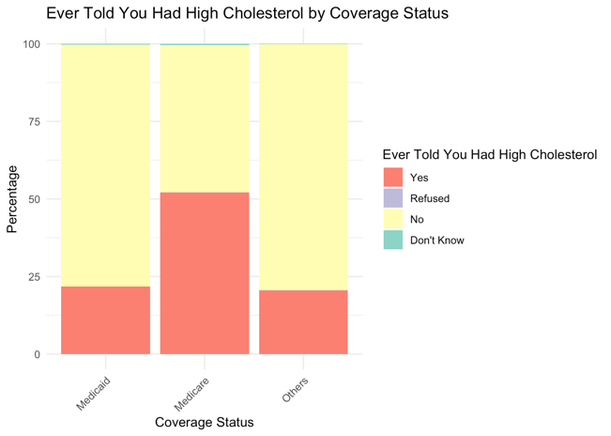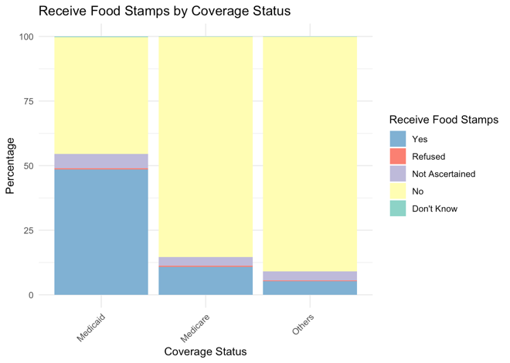

In terms of economic indicators, both the Income-to-Poverty Ratio and the general Poverty Ratio showed a slight decrease since 2020.

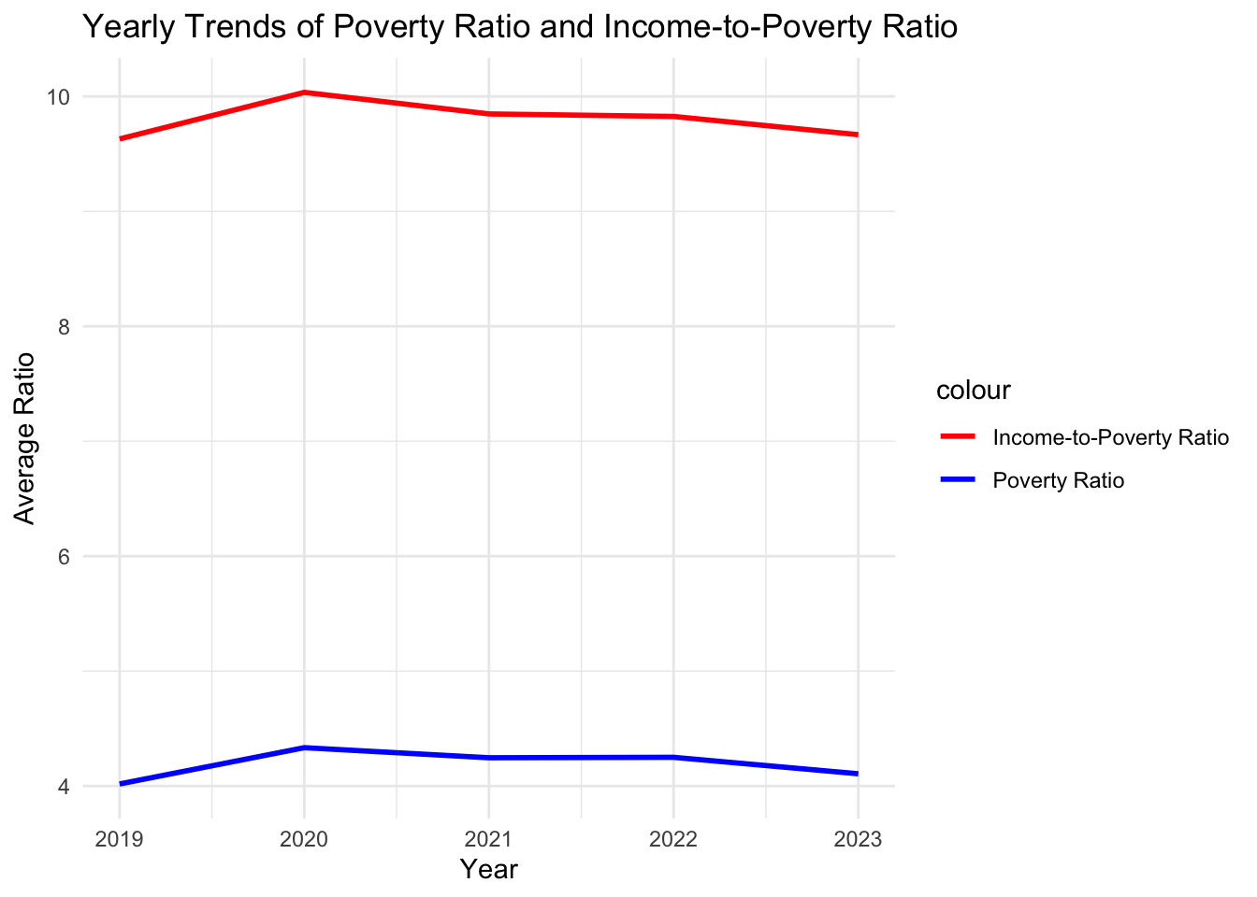

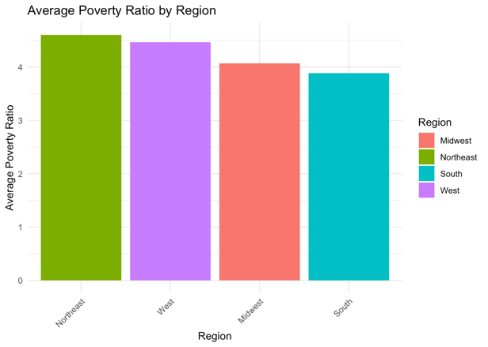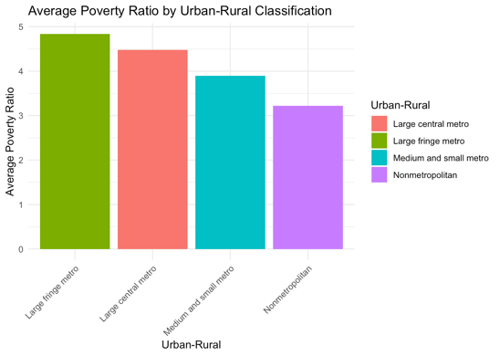

Finally, responses to major health-related questions in the NHIS survey remained generally consistent over the five-year period, with no large shifts observed in the overall patterns.

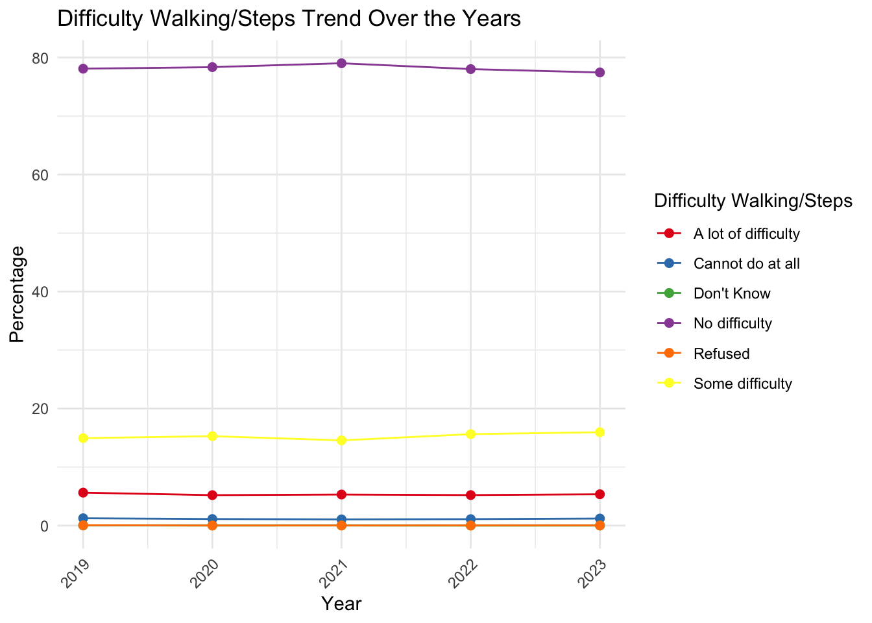

**3. Healthcare Infrastructure Trends (NaNDA)**

Over the past two decades, the total number of healthcare facilities has increased nationally, with facility counts nearly doubling during this period. The most substantial growth was observed in categories such as outpatient care, mental health services, home health services, and pharmacies. 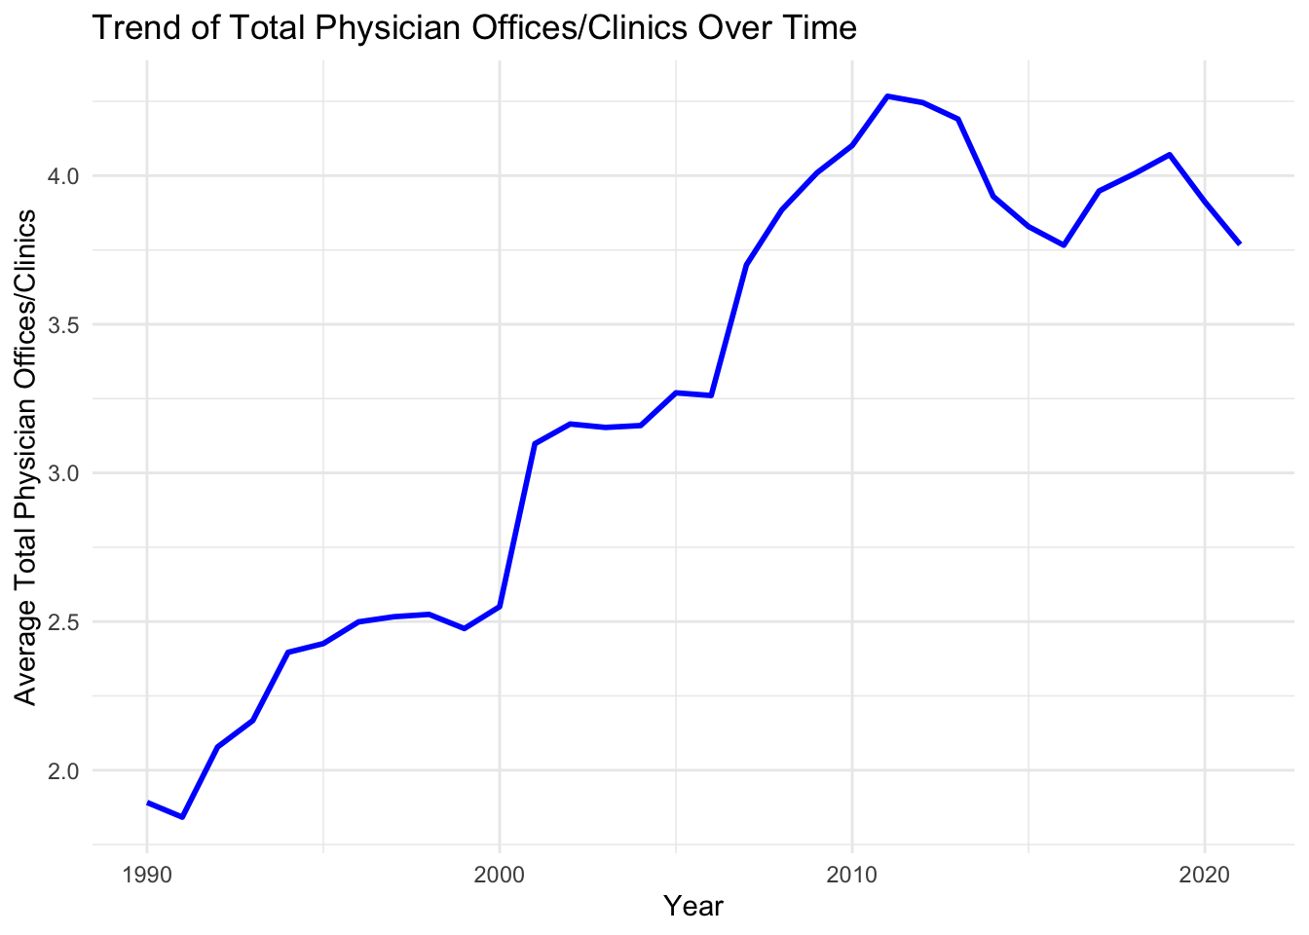

Despite this overall increase, regional patterns varied. In the Midwest, the number of physician offices and mental health clinics declined by approximately 50% over the past decade, which contrasts with the broader national trend. The South initially saw an increase in facility counts—particularly in home health and mental health services—but this growth slowed and began to reverse around 2020. Pharmacy availability remained relatively stable across regions, though the Midwest showed a temporary increase in 2020.

**4. Workforce Availability (AHRF + ACS)**

When adjusted for population using 2022 ACS data, healthcare workforce density showed no consistent regional patterns. Although health outcomes varied significantly by region, the per capita availability of healthcare professionals appeared relatively balanced across the country. This suggests that disparities in outcomes are not primarily driven by differences in provider headcounts.

**5. Cross-Regional and Urban-Rural Patterns**

**5.1 Health Outcomes by Region and Geography**

The Southern region reported the lowest average health status and the highest uninsured rates—about 5–7% higher than other regions. However, these disparities do not appear to stem from a lack of clinics or healthcare providers, as infrastructure availability was comparable across regions. Rather, they appear tied to lower average incomes, growing populations, and a greater share of rural residents.

**5.2 Racial Composition vs. Health Outcomes**

Racial composition alone did not account for regional health disparities. For example, the Midwest—with a largely White population (approximately 75%)—and the more racially diverse South (roughly 50% White) both reported similarly poor health outcomes. This suggests that regional and socioeconomic structures play a more decisive role than racial demographics in shaping health access and outcomes.

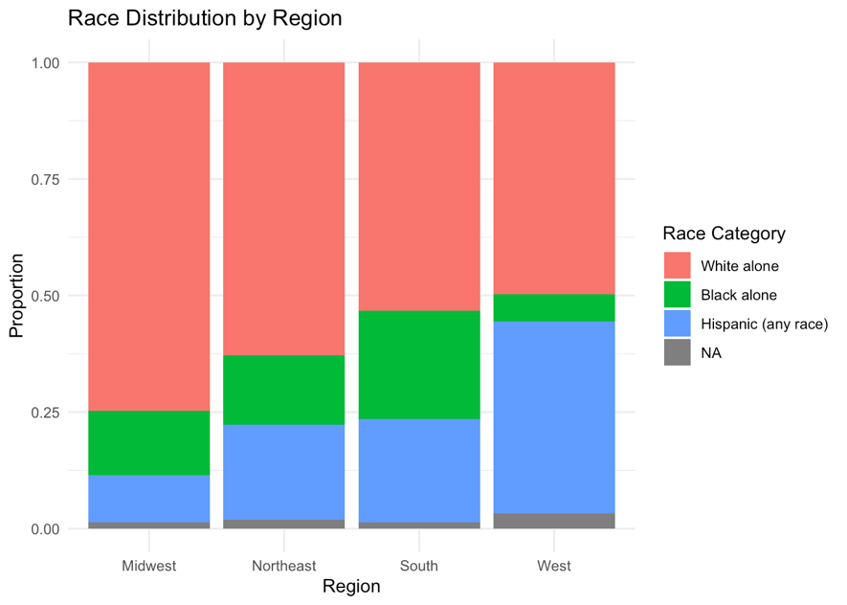

**5.3 Role of Income and Growth**

The most consistent correlations were observed between poverty rates, urban-rural classification, and general health status. Regions with higher rural populations and lower income levels consistently showed poorer outcomes. Notably, the South’s steady population growth—not matched by proportional expansion in healthcare services—may be contributing to increased pressure on existing systems and worsening health conditions.

**Discussion**

This study set out to examine disparities in healthcare access and utilization across rural and urban populations in the United States. By integrating multiple national datasets over a ten-year period, the analysis uncovered several key patterns that both reinforce existing literature and offer new insights into the structural factors shaping health inequities across regions and populations.

**1.Health Outcomes Are More Closely Linked to Socioeconomic Status Than Race or Provider Density**

A consistent theme across all datasets was the strong association between lower income levels and poorer health outcomes, particularly in rural and Southern regions. While racial disparities in insurance coverage—especially among Hispanic populations—remain evident, race alone did not explain the geographic variation in health status. Both the South (more racially diverse) and the Midwest (predominantly White) exhibited similarly poor outcomes, suggesting that economic vulnerability and geographic isolation are more influential drivers of disparities than racial composition alone.

Additionally, the study found no consistent regional differences in provider density that could account for these outcomes. This challenges assumptions that increasing provider counts alone is sufficient to reduce disparities.

**2. Rural Populations and the Southern Region Remain Disproportionately Disadvantaged**

The Southern region emerged as the most persistently disadvantaged in terms of health outcomes and insurance coverage, despite having comparable healthcare infrastructure to other regions. This suggests a growing mismatch between population growth and healthcare system capacity. Rural residents, especially in the South, reported lower health status.

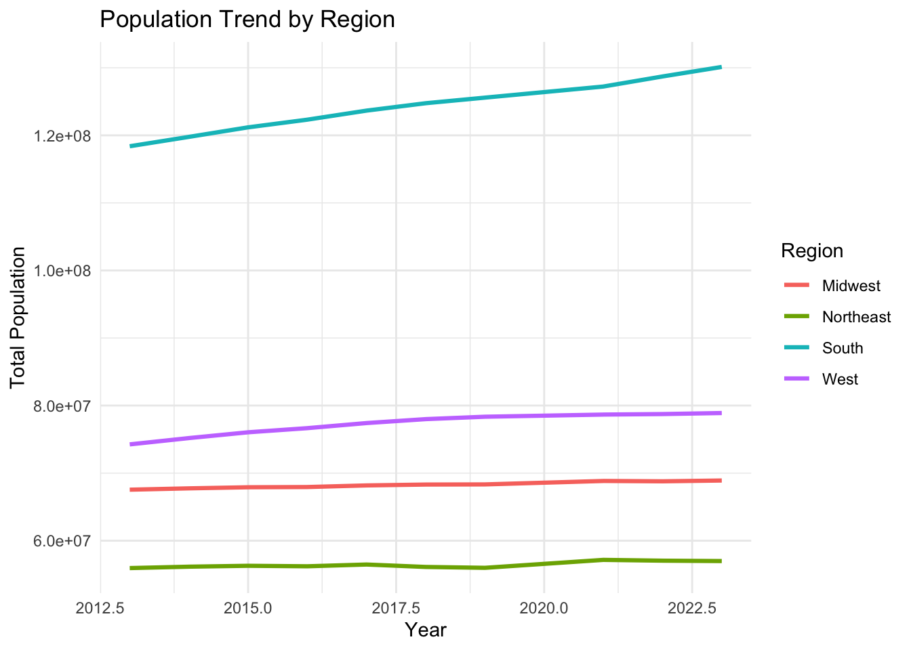

These findings confirm that rurality and regional context are not secondary variables, but central factors in determining healthcare access and equity. They reinforce earlier studies (e.g., Wolfe et al., 2020; Wang et al., 2022) that emphasize the compounding effects of geography on access and outcomes.

**3. Infrastructure Growth Is Uneven and Not Always Aligned with Need**

While national data show that the number of healthcare facilities has generally increased over the past two decades, this growth has not occurred evenly. The Midwest experienced significant declines in physician offices and mental health clinics. Similarly, the South saw early growth in facility counts, followed by declines after 2020.

These findings support the conclusion that expanding infrastructure alone is insufficient without considering equitable distribution and alignment with regional needs. Even areas with average or above-average provider density can face acute local shortages with serious consequences for access and outcomes.

**4. Study Contributions and Broader Implications**

This study makes several contributions to the field of healthcare equity:

* Integrated Analysis: It leverages multi-source, longitudinal data to triangulate findings across insurance coverage, infrastructure availability, population demographics, and health outcomes.
* Focus on Underserved Groups: It centers individuals with disabilities and public insurance users—populations that are frequently underrepresented in large-scale healthcare research.
* Structural Insights: It shows that geographic and socioeconomic variables intersect more significantly than race alone in shaping disparities.

From a policy standpoint, these findings suggest a pressing need for place-based and population-specific strategies. Investments should prioritize fast-growing, low-income rural areas—particularly in the South—where healthcare infrastructure has not kept pace with demographic shifts.

### ****Addressing Research Objectives****

### This study successfully addressed its three primary objectives through the integration of longitudinal and cross-sectional data from five national sources and a multi-layered analytical approach.

### First, the study identified clear disparities in healthcare access between urban and rural populations, with stratification by age, race/ethnicity, and income level. The findings revealed that lower income and rural residence were consistently associated with poorer health outcomes and lower insurance coverage, while race and provider density played a less consistent role in explaining geographic disparities. This pattern was particularly evident in the Southern and Midwestern regions, where health outcomes were disproportionately poor despite good infrastructure levels.

### Second, analysis of healthcare service utilization over the past decade showed a notable increase in reliance on public insurance programs, such as Medicaid and Medicare, across all regions. However, this rise in utilization was not matched by consistent infrastructure growth. The South and Midwest, for example, experienced declines in the number of physician offices and mental health clinics despite growing demand. These findings underscore the role of uneven infrastructure expansion and population-resource mismatches in shaping regional access trends.

### Third, the study examined variations in health insurance coverage and their impact on healthcare access. Medicaid and Medicare enrollees were more likely to report chronic conditions, functional limitations, and use of supplemental assistance programs like food stamps and WIC. These trends highlight how insurance status is tightly linked to structural vulnerability, especially in economically disadvantaged populations, and illustrate the compounding barriers faced by those relying on public health programs for care.

### ****Conclusion****

### This study underscores that healthcare disparities across urban and rural settings in the U.S. are driven less by infrastructure counts or racial composition, and more by socioeconomic vulnerability and geographic isolation. While health insurance coverage and healthcare infrastructure have improved nationally over the past decade, these gains have not reached all populations equally. Despite comparable provider availability, regions like the South and rural areas continue to report poorer health outcomes, reflecting deeper structural inequities. Targeted, region-specific policy responses that address both social and economic determinants are essential to advancing health equity—particularly for individuals with disabilities and those reliant on public insurance.

### Reproducibility and Future Use

### All analyses were conducted using RStudio, and the codebase has been developed in a fully reproducible manner. Scripts are modular and annotated to allow seamless integration of updated datasets in the future. Users can re-run the analysis with minimal adjustments by replacing the original data files, ensuring continuity and transparency for future research or policy evaluations.

**GitHub Repository:** [github](https://github.com/anvesh232/Equity_healthcare)

**References**

Agarwal, R., Sweeney, T. E., & Kwan, A. (2020). The impact of bundled payment on healthcare spending, utilization, and quality: A systematic review. *Health Affairs, 39*(1), 50–57. https://doi.org/10.1377/hlthaff.2019.00778

Bhatia, S., Bandera, A., Pezzi, C., & Patnaik, M. (2022). Rural–urban disparities in cancer outcomes: Opportunities for future research. *JNCI: Journal of the National Cancer Institute, 114*(7), 940–952. https://doi.org/10.1093/jnci/djab197

Cross, S. H., Califf, R. M., & Warraich, H. J. (2021). Rural-urban disparity in mortality in the US from 1999 to 2019. *JAMA, 325*(22), 2312–2314. https://doi.org/10.1001/jama.2021.5200

Gaffney, A. W., Dyer, D. J., Mikhail, J., & McNulty, T. (2022). Health care disparities across the urban-rural divide: A national study of individuals with COPD. *The Journal of Rural Health, 38*(2), 207-216. https://doi.org/10.1111/jrh.12518

Hardeman, R. R., & Karbeah, J. (2020). Examining racism in health services research: A disciplinary self-critique. *Health Services Research, 55*(Suppl 2), 777–780. https://doi.org/10.1111/1475-6773.13204

Morales, D. A., Barksdale, C. L., & Beckel-Mitchener, A. C. (2020). A call to action to address rural mental health disparities. *Journal of Clinical and Translational Science, 4*(5), 463–467. https://doi.org/10.1017/cts.2020.509

Moon, S., & Shin, J. (2006). Health care utilization among Medicare-Medicaid dual eligibles: A count data analysis. *BMC Public Health, 6*, 88. <https://doi.org/10.1186/1471-2458-6-88>

OpenAI. (2024). ChatGPT (December 19 version) [Large language model]. Retrieved from <https://chat.openai.com>

Schneider, A., Wagenknecht, A., Sydow, H., Riedlinger, D., Holzinger, F., Figura, A., & Möckel, M. (2023). Primary and secondary data in emergency medicine health services research – A comparative analysis in a regional research network on multimorbid patients. *BMC Medical Research Methodology, 23*, Article 188. https://doi.org/10.1186/s12874-023-02193-2

VanderWeele, T. J., & Vansteelandt, S. (2014). Mediation analysis with multiple mediators. *Epidemiologic Methods, 2*(1), 95-115. https://doi.org/10.1515/em-2014-0007

Wang, H., Hua, X., Yao, N., Zhang, N., Wang, J., Anderson, R., & Sun, X. (2022). The urban-rural disparities and associated factors of health care utilization among cancer patients in China. *Frontiers in Public Health, 10*, 842837. https://doi.org/10.3389/fpubh.2022.842837

Wolfe, M. K., McDonald, N. C., & Holmes, G. M. (2020). Transportation barriers to health care in the United States. *American Journal of Public Health, 110*(6), 815–822. https://doi.org/10.2105/AJPH.2020.305726

Zahodne, L. B., Templin, T., & Hassenstab, J. (2024). Neighborhood racial income inequality and cognitive health. *Alzheimer's & Dementia, 20*, 5338–5346. https://doi.org/10.1002/alz.13000

Zheng, X., & Dean, C. (2021). Model-based community health surveillance via multilevel small area estimation. *Behavioral Risk Factor Surveillance System*. https://doi.org/10.1155/2021/7427471

Wang, X., & Cheng, Z. (n.d.). Cross-sectional studies: Strengths, weaknesses, and recommendations. *CHEST*. https://doi.org/10.1016/j.chest.2020.07.054

Moon, S., & Shin, J. (2006). Health care utilization among Medicare-Medicaid dual eligibles: A count data analysis. *BMC Public Health, 6*, 88. https://doi.org/10.1186/1471-2458-6-88